Project 3:

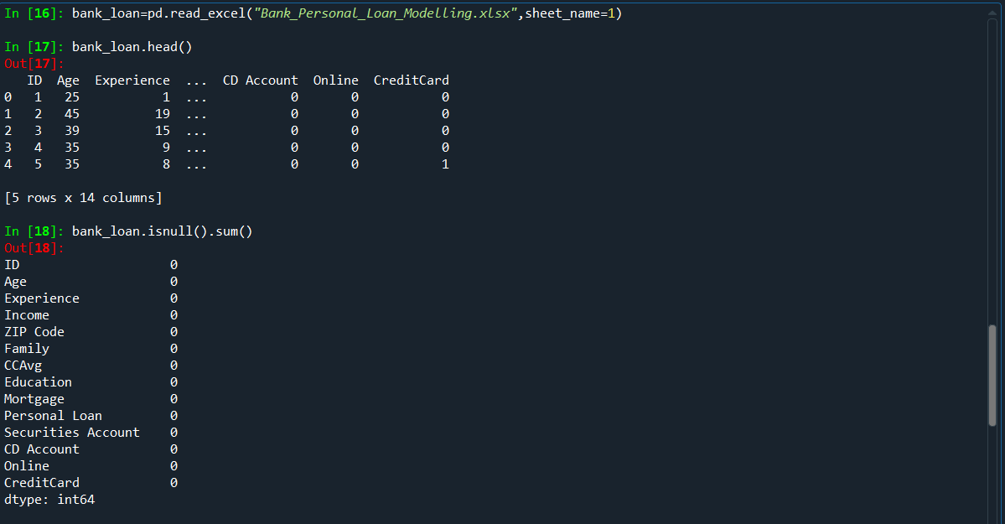

Checked for null values

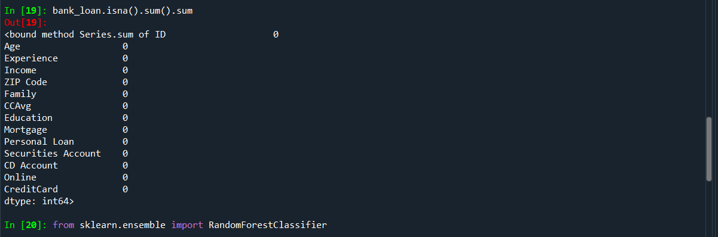

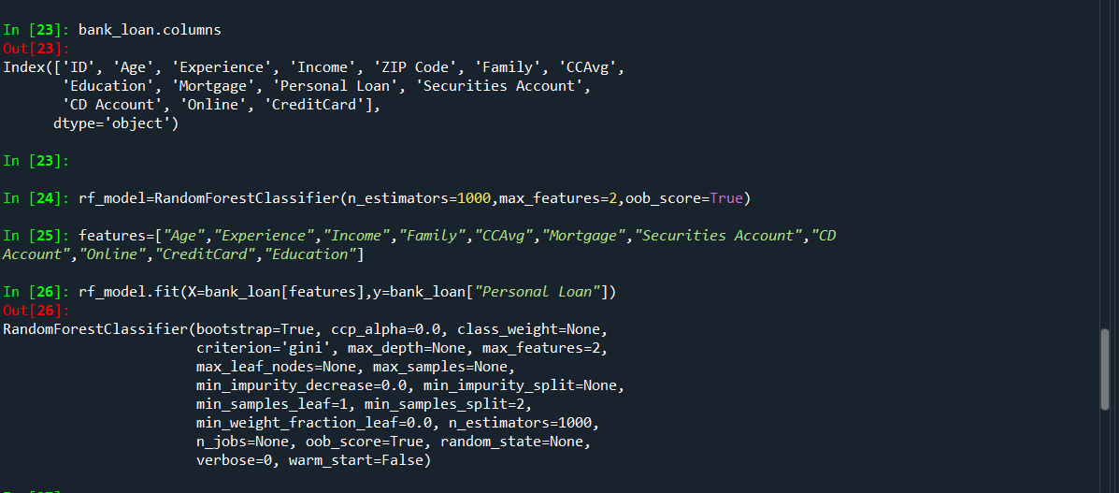

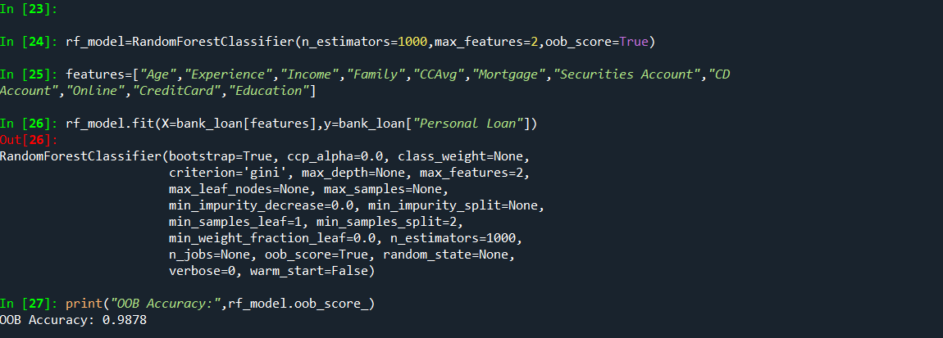

The accuracy got is 98%

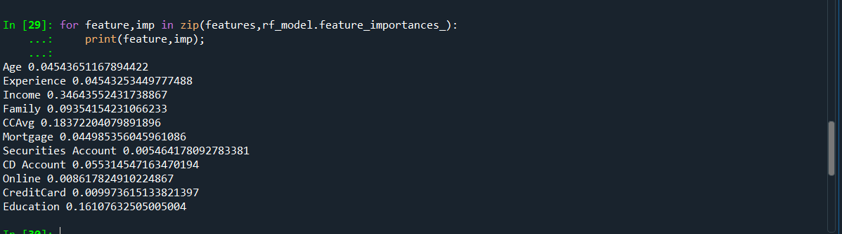

Identified the important variables for decision tree using random forest Algorithm

so based the output the important variables for decision tree are

1.Income

2.CCAvg

3.Education

So now using this 3 important variables we are going to create the decision tree model

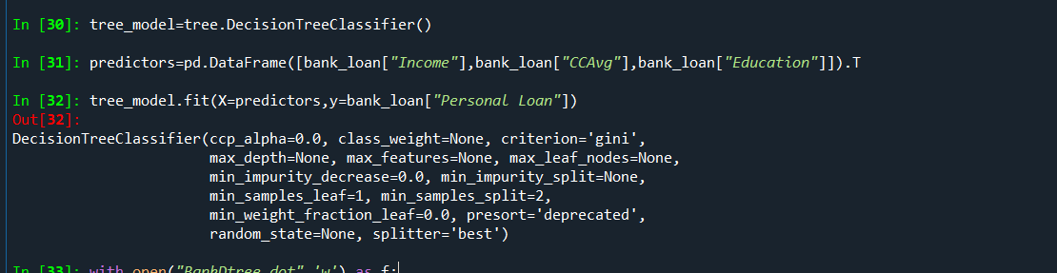

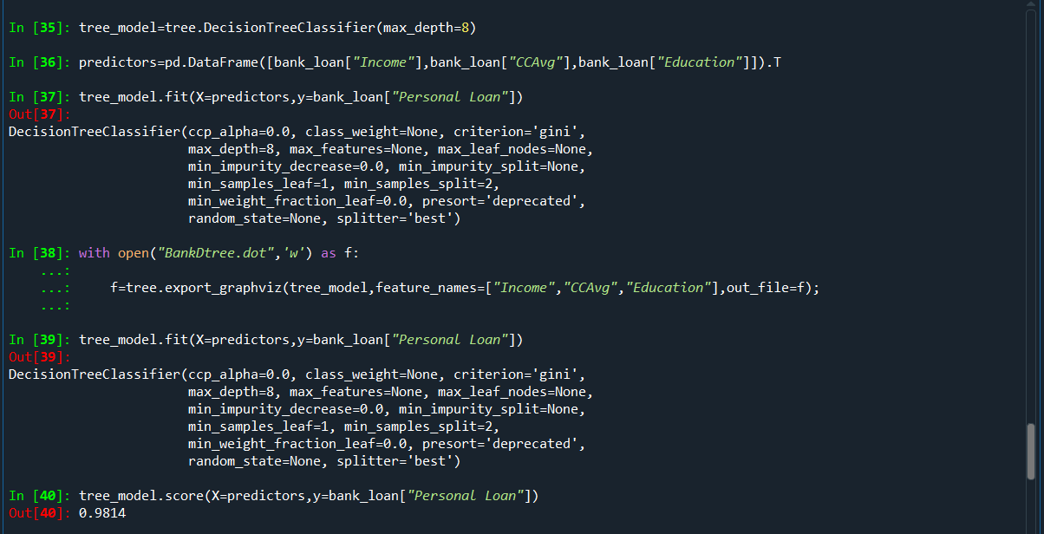

The accuracy of the model is 98%

